**Exploratory Crime Data Analysis: An Insight into crimes of USA**

1Prashant Singh,2Dr. Sanjay Jain, 3Rajat Singh Tomar

1,3*PG Students ,*2*Professor CSE*

1*Corresponding Author Email ID: ps47600@gmail.com*

*School of Engineering and Technology, ITM University, Gwalior*

**Abstract**

This data analysis focuses on exploring whether there is a correlation between gender demographics and the types of crimes they are more likely to be victims of. The study is based on the Gov Crime Data from Los Angeles, CA, USA, which is collected by the National Crime Victimization Survey (NCVS) to keep track of crime data. By examining the prevalence of different types of crime victimization among men, women, non-binaries, and other genders, this analysis aims to provide valuable insights into the nature and extent of crimes based on gender demographics. However, the data collected by NCVS contains many discrepancies and outliers that need to be cleaned before proceeding with analysis. This involves identifying and removing any erroneous data points, and transforming the data to a format that can be easily analyzed. Once the data is cleaned, various statistical and visual analyses can be conducted, providing valuable insights into the hidden trends in the data. For example, the analysis might reveal the variance in gender-based crimes, the types of weapons most commonly used in crimes, and other patterns in the data that may not have been immediately apparent. By identifying these hidden trends, the analysis can help to inform law and order systems in the city to introduce protective measures to reduce the occurrence of crimes. For instance, if the analysis finds that women are more likely to be victims of a certain type of crime, the law enforcement agencies can introduce measures to protect women from that type of crime. Similarly, if the analysis identifies a pattern in the types of weapons used in crimes, this information can be used to introduce measures to reduce the availability of those weapons and decrease their use in crimes. Ultimately, the insights provided by this analysis can help to improve public safety and reduce crime rates in Los Angeles, CA, USA. **Keywords***: Crime victimization, Los Angeles, CA, USA, Statistical Analysis, Visual Analysis, Crime Rates, Law Enforcement Measures.*

1. **Introduction**

Crime data analysis is a critical need in the United States due to the increasing number of crimes committed each year. The data collected through various sources such as police reports, surveys, and victimization studies can provide valuable insights into the nature and extent of crime in different regions. Crime data analysis is necessary to identify trends and patterns in crime, including the types of crimes committed, their frequency, and locations. By analyzing this information, law enforcement agencies and policymakers can develop effective strategies to reduce crime rates and improve public safety. Moreover, crime data analysis can help identify gaps in law enforcement measures and address issues related to social and economic inequalities, which can contribute to higher crime rates in certain areas.

The US government and law enforcement agencies collect crime data from various sources and maintain a national crime database to keep track of crimes committed in the country. However, crime rates and trends can vary significantly across different US states due to factors such as demographics, socio-economic status, and culture. By analyzing crime data at the state level, it is possible to gain valuable insights into the nature and extent of crime, as well as the effectiveness of law enforcement measures in different regions. This information can then be used to develop and implement policies and strategies that can help prevent crime and improve public safety in US states. Therefore, crime data analysis is an essential tool in ensuring the security and well-being of the citizens of the United States.

1. **Previous works**

In the domain of Crime Data Analysis, a constellation of seminal works has significantly contributed to comprehending and mitigating criminal activities through diverse spatio-temporal and statistical methodologies. Kelvin Leong and Anna Sung's exhaustive review scrutinizes spatio-temporal pattern analysis, accentuating five pivotal categories: spatial pattern, temporal pattern, frequent spatio-temporal pattern, unusual spatio-temporal pattern, and spatio-temporal effects due to intervention. The document underscores the criticality of such analyses in identifying crime hotspots, discerning trends, and formulating efficacious intervention strategies, demonstrating the application of data mining techniques across distinct patterns. [1]

The contribution of "Sahar Bayoumi, Sarah AlDakhil, Eman AlNakhilan, Ebtehal Al Taleb, Hana AlShabib" lies in a case study on crime analysis and visualization in Maryland State, USA. Focusing on spatial and temporal dimensions and leveraging data from 2016, the authors reveal the instrumental role of crime mapping in pinpointing hotspots, discerning trends, and unraveling patterns. The study elucidates the potential of such analyses for law enforcement agencies to craft precision-targeted strategies for crime prevention. [2]

Turning attention to statistical methodologies, Wim Bernasco and Henk Elffers furnish a comprehensive overview of spatial statistical methods for analyzing crime data. Distinguishing between spatial distribution data and movement data, the authors explore an array of models, including spatial regression, spatial filtering, geographically weighted regression, spatial interaction, and discrete choice models. Through illustrative examples, they underscore how these methods unveil insights into crime patterns, underscoring their indispensability despite challenges such as the modifiable areal unit problem. [3]

The assimilation of machine learning into crime analysis is examined by "Suhong Kim, Param Joshi, Parminder Singh Kalsi, and Pooya Taher." Employing classification algorithms like K-nearest neighbor and boosted decision tree, they prognosticate crime types in Vancouver. Despite reporting relatively modest accuracy, the authors posit the potential for enhancement through algorithmic and data refinement, acknowledging the intricate nature of real-world crime data. [4]

In the context of Nigeria, "Pelumi E.Oguntunde, OluwadareO.Ojo, Hilary I. Okagbue, Omoleye A. Oguntunde" scrutinize selected crime data, unveiling intricate relationships between diverse crime typologies. The study posits a need for further research to fathom these relationships and devise effective crime prevention strategies. Emphasizing regional variations in crime rates and the imperative of addressing root causes such as poverty and unemployment, the research underscores the multifaceted nature of criminal dynamics. [5]

Transitioning towards a prognostic paradigm, "Shiju Sathyadevan, Devan M.S, Surya Gangadharan. S" propound a system leveraging data from heterogeneous sources to predict regions predisposed to crime. Employing a Naive Bayes classifier, Named Entity Recognition, and Coreference Resolution, the system attains over 90% accuracy in predicting crime patterns. The visualization of crime-prone areas augments law enforcement agencies' capacity for judicious resource allocation. [6]

Collectively, these scholarly endeavors constitute a rich mosaic of methodologies, ranging from spatio-temporal pattern analysis and statistical modeling to machine learning and prognostic systems. Each contribution imparts invaluable insights into comprehending, visualizing, and anticipating crime patterns, furnishing a robust framework for continued advancements in the domain of Crime Data Analysis.

1. **Proposed Methodology**
2. *Data collection*
3. *Data cleaning and preparation*.
4. *Data Analysis*
   1. *Quantitative Analysis Results*
   2. *Visual Analysis Results*
   3. *Spatial analysis Results*
5. *Conclusion and Recommendation*

Above steps have been done using python’s Pandas, MatPlotLib, Seaborn and folium library to successfully analyse the data.

1. **Data Collection**

The importance of obtaining valid and accurate data cannot be overstated in any research or analysis. The reliability of research outcomes is dependent on the validity and accuracy of the data being used. Data must be collected with utmost care and attention to detail to ensure that it is accurate, complete, and relevant to the research questions being addressed. Accurate data is essential for making well-informed decisions, policies, and interventions that can significantly impact individuals and society. On the other hand, relying on inaccurate data can lead to flawed policies and ineffective interventions that can have negative consequences for individuals and society at large. In fields such as crime data analysis, where the stakes are high, ensuring the validity and accuracy of data is particularly crucial. The consequences of incorrect data can be severe, leading to misguided policies and failed interventions that can have long-lasting and devastating effects. Therefore, it is vital to prioritize the collection and maintenance of accurate and valid data to ensure the reliability and effectiveness of research and analysis in all fields. The data source used in this project has been extracted from the existing data  
on Catalog.Data.Gov site

Dataset Link: [Gov Crime Data from Los Angeles, CA, USA](https://catalog.data.gov/dataset/crime-data-from-2020-to-present) [7]

An instance from the dataset:

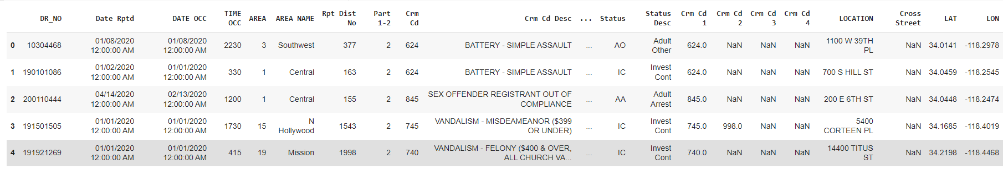



1. **Data Cleaning and Pre-processing**

Mixed data in a data set can be a challenge when performing data analysis. Mixed data refers to data sets that contain both numerical and categorical data. While numerical data can be easily analyzed using mathematical and statistical tools, categorical data requires different approaches to extract meaningful insights. One cannot perform analysis on mixed data directly, and it is essential to manipulate the data to create new data sets that can be analyzed using statistical and mathematical tools. This requires data manipulation techniques such as one-hot encoding, label encoding, and feature scaling. By creating new data sets that contain only numerical data or properly encoded categorical data, it becomes possible to perform analysis and extract meaningful insights. Therefore, data manipulation is an essential step in the data analysis process, particularly when dealing with mixed data. It ensures that the data is in the correct format for analysis and leads to more accurate results.

From the given dataset I have dropped multiple attributes that were inducing redundancy.

I have removed ‘Crm Cd Desc', 'AREA NAME', 'Premis Desc', 'Weapon Desc','Status Desc', ,'Cross Street' as these were already referenced with their respectable codes as given and table below. I have removed 'DR_NO', 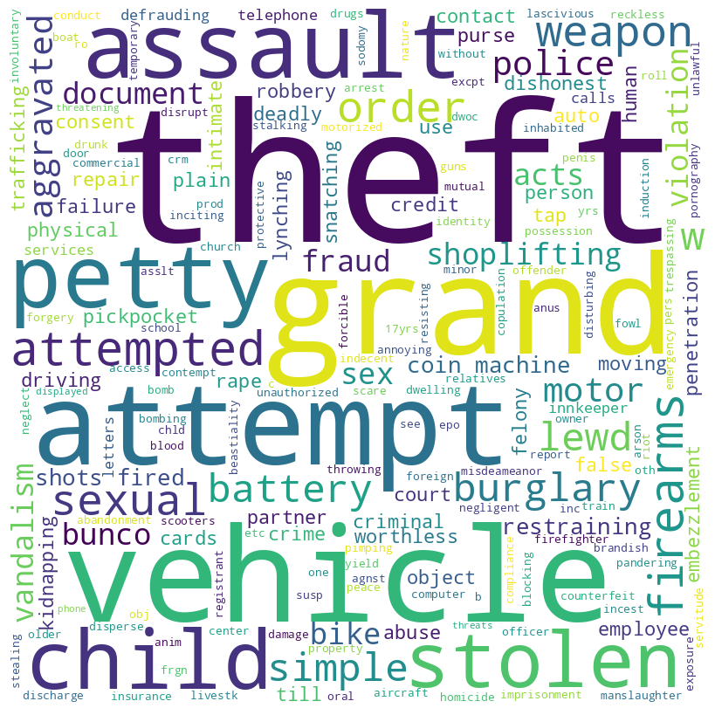'Mocodes','LAT','LON','LOCATION','Vict Descent','Crm Cd 1','Crm Cd 2','Crm Cd 3','Crm Cd 4' as these values were not required for the analysis.

I have also removed the crimes whose count was less than the threshold value of 1000 as these were very negligible and only occur seldomly in random pattern which is why it is not usable in our analysis.

Instance from the new Dataset:

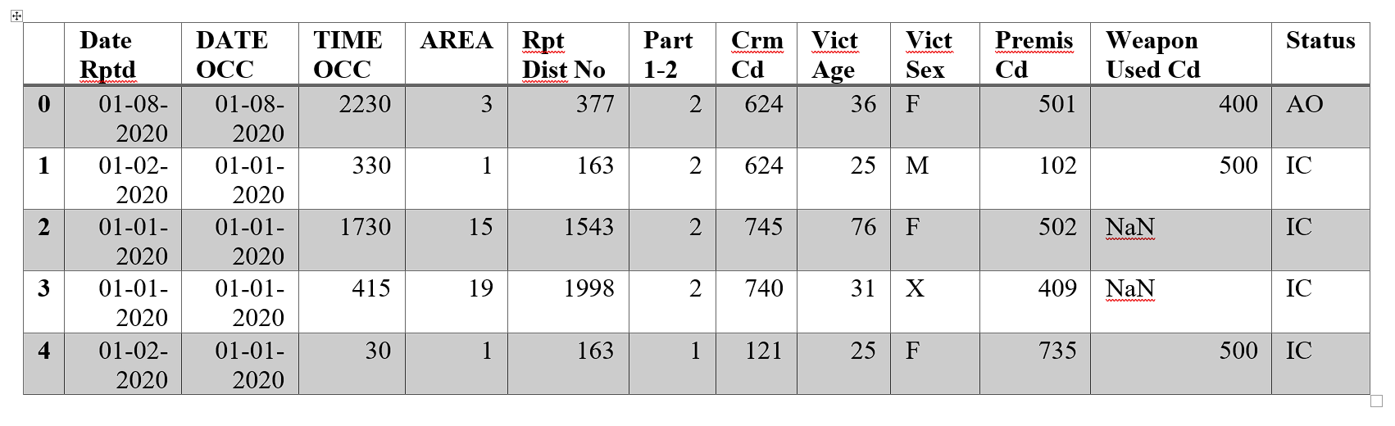

Apart from this pre-processing, I have processed data during the analysis part as per required context for example data grouping, creation of new data like percentages and similar tasks.

1. **Data Analysis**

Crime data analysis is crucial in understanding crime patterns and trends, as well as the effectiveness of law enforcement measures in preventing and responding to crime. It can provide valuable insights into the nature and extent of crime in a given area, as well as the demographic groups that are most at risk of being victimized. By analyzing crime data, policymakers and law enforcement agencies can identify areas where crime is most prevalent and implement targeted interventions and policies to prevent and reduce crime. This information can be used to allocate resources more efficiently and effectively, as well as to develop evidence-based strategies for improving public safety.

Moreover, crime data analysis can also help in identifying new types of crime, emerging crime trends, and the geographical patterns of crime. It can provide valuable information on the causes of crime, such as poverty, unemployment, or social inequality, which can help policymakers in developing strategies to address the root causes of crime. Additionally, crime data analysis can be useful in evaluating the effectiveness of various crime prevention and intervention programs, and identifying areas where improvement is needed.

* 1. **Quantitative Analysis Results**

Quantitative analysis plays a crucial role in crime data analysis. It is essential to use quantitative methods to analyze crime data as it provides an objective and systematic approach to examine patterns and trends in criminal activity. Quantitative analysis involves the use of statistical and mathematical methods to identify patterns, relationships, and correlations in the data.

Firstly, I have grouped the data with respect to crime codes so we can take a look at what are the figures of occurrence for each crime data. From the figure 1, the mean of this data represents that on average there are ***13461*** cases of crime for each code per year, which when taken in consideration with the size and population of Los Angeles may seem average but this data also includes violent crimes such as assault and battery, which emphasizes the role of police and executives that can lead to more peaceful society.

Also looking at the figure 1 and taking in consideration of the skewness of the data is ***1.61548908283905***16 and kurtosis of the same is ***2.0767431849393554***, suggests that there are some crimes which occur more frequently than others. These crimes are small crimes like petty theft, shoplifting, burglary and etcetera.

*Figure 1*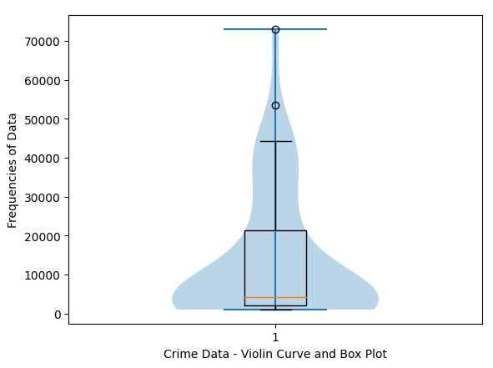



*Table 1: Crime Case Proceedings*

From the table 1, we can observe how the criminal case proceeding have been throughout the year for each individual proceeding type. I have taken only the top 5 crimes for each proceeding as they will give an easy indication for the whole type.

From part 1 of table 1, we can infer that these types of crimes are prevalent among adults and that law enforcement agencies are actively pursuing and arresting the suspects. The high occurrence of ***assault***, ***felony*** of $400 or more, ***robbery***, and ***burglary*** cases also suggests that there may be underlying socio-economic factors that contribute to these crimes.

From part 2 of table 1, we can infer that in these cases, the law enforcement officials may have chosen to resolve the situation without making an arrest as these cases include crimes such as ***simple*** ***assault***, ***aggravated*** ***assault*** and ***criminal*** ***threats***. It is possible that they used alternative methods such as mediation or counselling to address the situation. Alternatively, the convict may have turned themselves in voluntarily, or the authorities may have decided that an arrest was not necessary given the circumstances of the crime.

From part 3 of table 1, we can see one of the outliers of the data or rather outlier of nature as it is one-of-a-kind case which is not very helpful in analysis.

From part 4 of table 1, upon examining the crime data, it is evident that the majority of cases are currently in an "investigation continued" status. This raises questions about the efficiency and effectiveness of the law enforcement and court system. Specifically, it could suggest a lack of prompt police action or delays in the court proceedings. Notably, the crimes that are most commonly associated with this status include ***stolen*** ***vehicle*** or ***valuable*** ***items***, ***theft*** of ***identity***, and ***burglary***.

From part 5 of table 1, analyzing the cases where juveniles have been arrested for specific criminal cases, we observe that the crimes include ***robbery***, ***aggravated*** ***assault***, ***vandalism***, and ***stolen*** ***vehicles***. This may indicate a need for increased focus on prevention and intervention programs for at-risk youth to address the root causes of such criminal behaviour. It is also important to ensure that the juvenile justice system is providing appropriate rehabilitation and support to help these young individuals become productive members of society.

At last, from part 6 of table 1, this section highlights the relatively lower number of cases involving juvenile offenders that have been processed through means other than arrest. These cases primarily involve offenses such as ***assault***, ***criminal*** ***threats***, ***shoplifting***, and ***battery***. While the number of cases in this category is lower than others, it is important to note that these crimes can still have a significant impact on the victims and the community. It may also suggest that law enforcement and the justice system are taking proactive measures to divert juvenile offenders away from the criminal justice system, where appropriate.

Table 2: Weapon-Crime Relation

Now taking a look at table 2, it gives a brief description how weapons are related some specific crimes. From the dataset we can clearly see that not all the crimes include any weapon usage but majority does, ***235771*** number of cases include weapon usage to be exact.

Now for analysis I have taken all the weapon categories which have a cumulative count of more than ***17000***. This gives us ***13*** categories which makes ***93.7***% of the whole cases.

For the first row of weapon types, these includes fire arms such as ***pistol***, ***shot*** ***guns***, ***semi***-***automatic*** ***firearms***. Due to the less restrictive laws for firearms bearing in the USA we can see that number of cases including firearms are on average higher than any other country, specifically for semi-automatic and automatic types of firearms.

In the next row, weapons that result in blunt force attack are included for example ***thrown*** ***object*** like rock or brick, ***vehicle*** ***hit*** and ***metal*** ***pipe*** ***hit***. These are relatively less in count.

The next row shows the cases with sharp edged weapon like ***knives*** and ***broken*** ***bottle*** which are relative to aggravated assault, threats and brawls, generally occurring near bars, pubs and casinos, indicating the usage on high value targets with wealthy possessing.

The last set of groups are related to the most common types of violence that is ***melee*** or ***hand*** ***to*** ***hand*** ***fighting***, ***verbal*** ***abuse*** and ***pepper*** ***sprays*** (generally used for self-defence). As most people don’t carry any weapon on them every time, general crime occurs in this category. The numbers also back up this assumption as melee makes up for almost ***51.8%*** of cases that include some or the other kind of combat engagement.

* 1. **Visual Analysis Results**

Visualizations are a critical component of crime data analysis, as they provide an effective way to communicate complex information in a clear and concise manner. Crime data can be vast and complex, and visualizations help to distil this information into meaningful insights and patterns that can be easily understood.

Visualizations also allow for the identification of trends and patterns in crime data that may not be immediately apparent from the raw data. For example, a map of crime incidents in a particular area can help to identify high-crime areas and patterns of criminal activity. Similarly, a graph of crime rates over time can reveal long-term trends in criminal activity and highlight areas where law enforcement efforts have been successful or where more attention is needed.

From figure 2, the extreme ends of the describe crime for female gender on left and male gender on right and from there the difference between them decreases until minimal in the middle. This graph indicates that some crimes are targeted to one specific gender more than the other.

In case of crimes that have more female victims, it includes ***121:"RAPE, FORCIBLE", 860: BATTERY WITH SEXUAL CONTACT, 812: CRM AGNST CHLD (13 OR UNDER) (14-15 & SUSP 10 YRS OLDER).*** This insight suggests that generally females are subject to sexual harassment and battery.

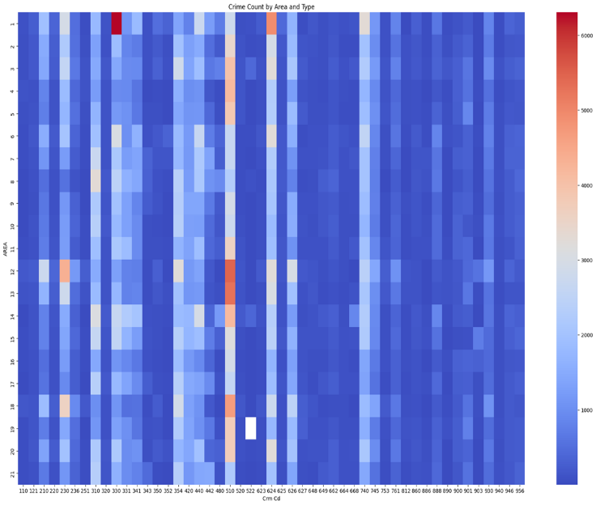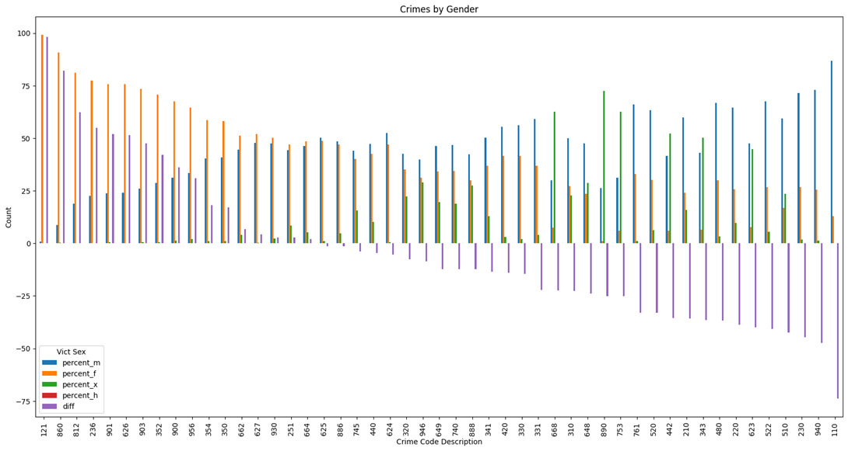

*Figure 2: Crimes by Gender*

While on the other hand, for male counterparts the suffer from ***110: CRIMINAL HOMICIDE, 940: EXTORTION, 230: "ASSAULT WITH DEADLY WEAPON, AGGRAVATED ASSAULT"***. Therefore, males are more prone to fall victim of a deadly and violent crime than women.

In the middle of the pack we can observe crimes like ***946: BIGAMY*** (Extra Marital Affair), ***649: DOCUMENT FORGERY*** and ***740: VANDALISM,*** which are very in-line with their characteristics.

This insight is helpful in suggesting the law makers, executives and police to increase vigilance for these specific crimes for each gender respectively.

From figure 3, we can see the distribution of the crimes in each Area code in the city of Los Angeles. It is observable that crime ***510: VEHICLE STOLEN*** is the most frequent crime out of all the other crimes in each sector followed by ***624: BATTERY - SIMPLE ASSAULT***. Area 12 and 13 see a shared average max of around 5100 in each for the same indicating it as an office or public place where vehicle is left unattended for and generally get stolen. Next, we can also see some random spikes of frequency in various crimes of various areas. The most prominent of all is ***330: BURGLARY FROM VEHICLE*** in AREA 1, where its frequency is approximately at 6200. This begs for the need of increased surveillance in the area and more vigilantism. Apart from that there

*Figure 3: Area-Wise Crime*

are various spikes like ***625: OTHER ASSAULT*** in AREA 1, ***230: ASSAULT WITH DEADLY WEAPON, AGGRAVATED ASSAULT*** in AREA 12 and AREA 18.

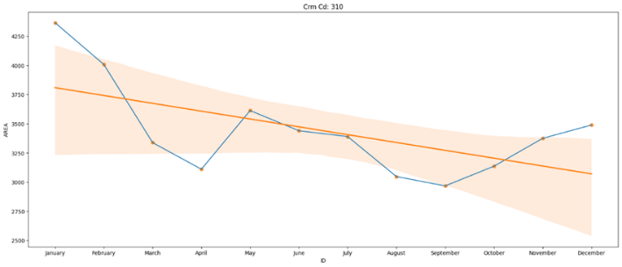

*Figure 4.1: Monthly Trend of 230: Assault with deadly weapon*

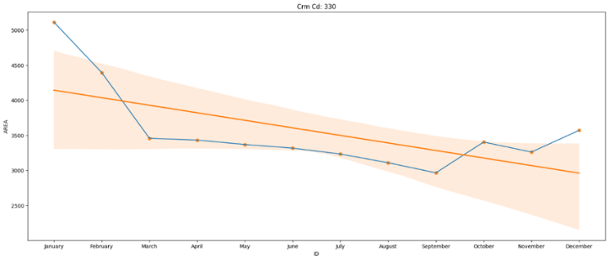

*Figure 4.2: Monthly Trend of 310:* *Burglary*

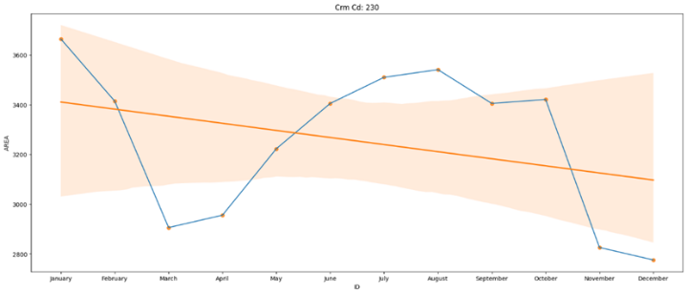

*Figure 4.3: Monthly Trend of 330:* *Burglary from Vehicle*

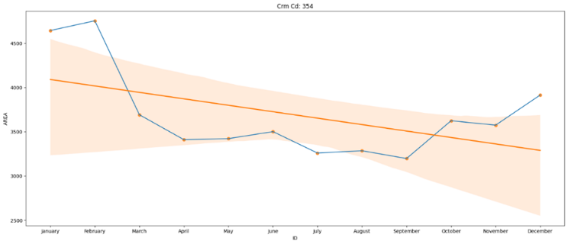

*Figure 4.4: Monthly Trend of 354:* *Theft of Identity*

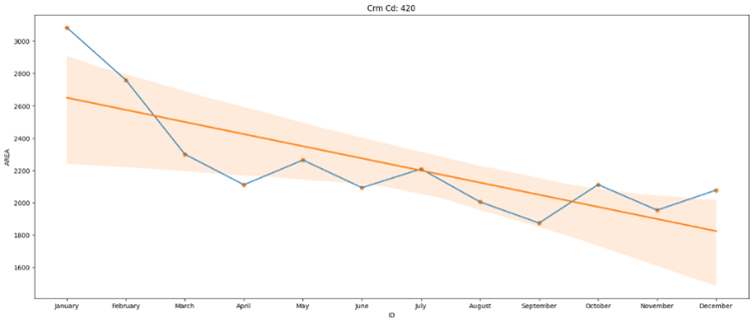

*Figure 4.5: Monthly Trend of 420: Theft from Motor Vehicle - Petty ($950 & under)*

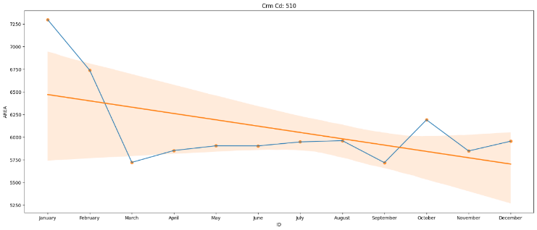

*Figure 4.6: Monthly Trend of 510: Vehicle - stolen*

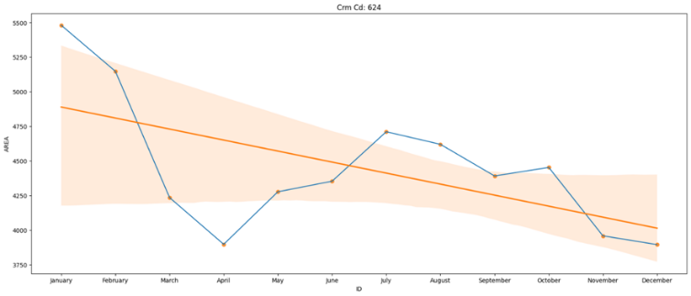

*Figure 4.7: Monthly Trend of 624: other assault*

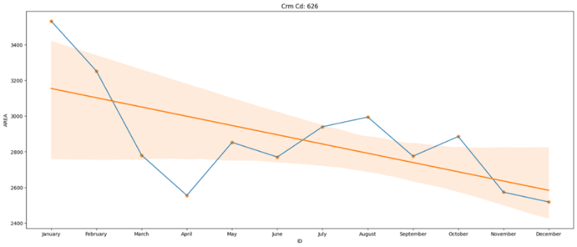

*Figure 4.8: Monthly Trend of 626:* *Intimate Partner - Simple Assault*

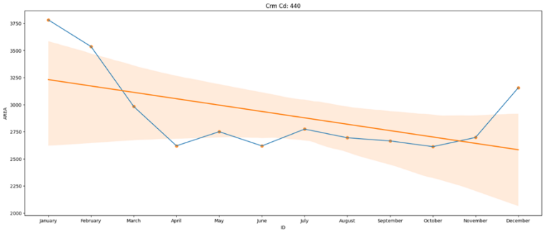

*Figure 4.9: Monthly Trend of 440:* *Theft Plain - Petty ($950 & under)*

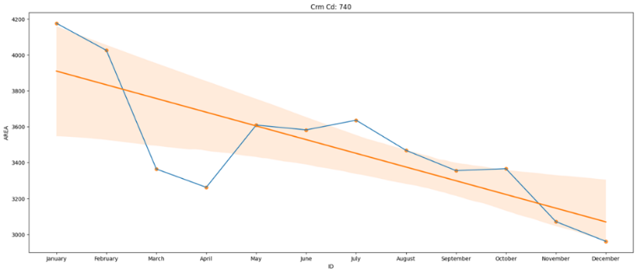

*Figure 4.10: Monthly Trend of 740:* *vandalism - felony ($400 & over, all church vandalisms)*

The figure above that is from 4.1 to 4.10 show the monthly trend of top 10 most frequent crime cases. These cases are generally divided into two categories burglary (***fig 4.2, 4.3, 4.4, 4.5, 4.6, 4.9, 4.10***) and assault (***fig 4.1, 4.7, 4.8***). We can observe that all the crimes have a downward trend through the year with spikes around the months of July, August and October.

From the ***fig 4.1, 4.7*** & ***4.8***, upon analyzing the assault-related crimes, a recurring trend can be observed where the frequency of such crimes declines during the first quarter of the year, followed by a subsequent rise. This decline could possibly be attributed to the post-holiday season lull and a general lack of enthusiasm among people. However, as the year progresses, the number of assault cases gradually increase, with peak values generally observed in either August or October. This uptick in assault crimes could possibly be attributed to the onset of the festive season, leading to heightened emotions and incidents of aggression.

From the ***fig 4.2, 4.3, 4.4, 4.5, 4.6,*** & ***4.9*** it is noticeable that the occurrences of burglary and theft crimes increase during the onset and conclusion of the year, particularly during the holiday season, which is a time when individuals tend to purchase new items for themselves or as gifts. This is typically when the highest number of burglary incidents take place, highlighting a potential link between the holiday season and an increased risk of theft or burglary. While it is true that the holiday season can lead to an increase in theft and burglary, there could be other factors at play as well, such as increased darkness during the winter months or an increase in property values due to the real estate market.

* 1. **Spatial Analysis Results**

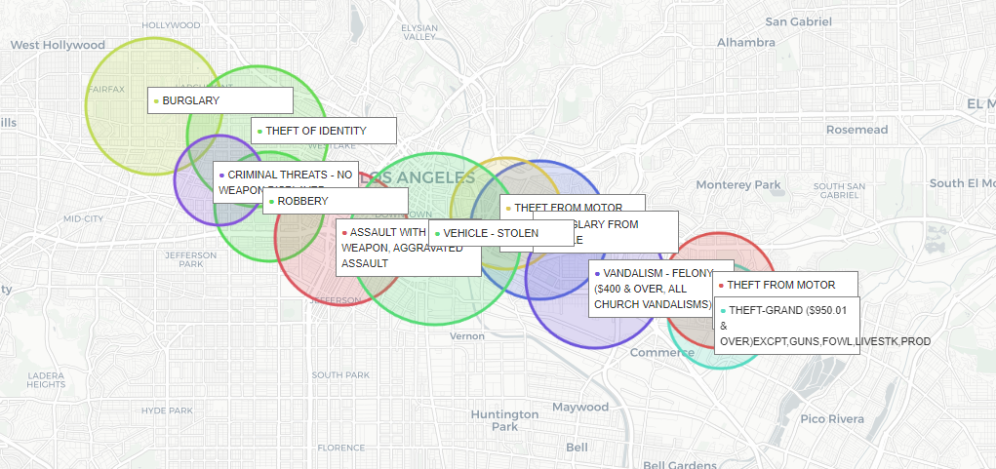The map shows that the area from West Hollywood to Commerce in Los Angeles has a high rate of robberies, burglaries, thefts, and other felonies. This is likely due to a number of factors, including the area's high concentration of luxury businesses and attractions, its large transient population, and its reputation as a safe haven for criminals. West Hollywood and Commerce are located in the heart of Los Angeles, and they are home to a number of high-end stores, restaurants, and nightclubs. These businesses attract a large number of tourists and visitors, many of whom are carrying cash and valuables. This makes the area a prime target for criminals.

*Map1: Group 1 of Crimes, From West Hollywood to Commerce via Downtown, LA*

In addition, West Hollywood and Commerce have a large transient population. This includes people who are homeless, people who are living in shelters, and people who are traveling through the area. These people are often desperate for money, and they may be more likely to commit crimes in order to get it.

Finally, West Hollywood and Commerce have a reputation as a safe haven for criminals. This is due in part to the fact that the area has a large LGBTQ+ community. This community is often seen as being tolerant of crime, and it may be more difficult for law enforcement to investigate crimes in the area. The combination of these factors makes West Hollywood and Commerce a high-crime area

1. **Conclusion and Recommendation**

In summary, the analysis of crime data in the Los Angeles area has provided valuable insights into the types of criminal activities that are more prevalent, their seasonal trends, and the differences in legal proceedings taken against adult and juvenile offenders. The study found that theft, burglary, and vandalism were the most common crimes reported in the area, with a clear increase in the number of incidents during the holiday season. This rise in criminal activity during the holiday season can be attributed to the increase in consumer spending, with people buying new products for themselves or as gifts.

Interestingly, assault and robbery showed a trend of decreasing in frequency in the first quarter of the year, likely due to the winter weather and people spending more time indoors. However, as the year progresses, the frequency of these crimes starts to rise again, peaking in either August or October.

The analysis also revealed that cases involving juvenile offenders were more likely to result in other proceedings besides arrest, such as diversion or community service. This may indicate that the criminal justice system is taking a more rehabilitative approach towards young offenders. In contrast, adult offenders were more likely to be arrested and have formal charges filed against them.

Furthermore, the analysis highlighted the different types of crimes committed by adults and juveniles, with assault, felony, robbery, and burglary being the most common crimes leading to arrest for adults, while robbery, aggravated assault, vandalism, and stolen vehicles were the most common crimes leading to arrest for juveniles. Meanwhile, both adults and juveniles had the highest number of cases where proceedings were other than arrest for crimes such as assault, criminal threats, and shoplifting.

To summarize, the analysis of crime data in the Los Angeles area reveals that the high crime rate in West Hollywood and Commerce can be attributed to factors such as the presence of luxury businesses attracting potential targets, a transient population with economic challenges, and a perception of leniency toward criminal activities. Understanding these factors is crucial for law enforcement agencies and policymakers to develop effective strategies to combat crime, enhance public safety, and potentially consider measures like increased police presence during peak periods or specific community outreach initiatives.

These findings can be valuable to law enforcement agencies and policymakers, as they can help them take necessary measures to prevent crime and improve public safety. For example, policymakers could consider increasing police presence during the holiday season to deter theft and burglary. Moreover, they could evaluate the effectiveness of current rehabilitation programs for juvenile offenders and consider implementing similar programs for adult offenders. Overall, the analysis provides a useful snapshot of the crime trends and patterns in the Los Angeles area, which can inform crime prevention strategies and efforts to improve the criminal justice system.

## **Recommendation for Public Safety**

To combat the rising cases of burglary, theft, and robbery, a comprehensive approach to crime prevention is necessary. Increasing police presence through additional patrols deters criminals and makes their operations more difficult. Improved security measures, such as installing surveillance cameras and hiring security guards, enhance safety in public areas and businesses. Rehabilitation programs for adult and juvenile offenders help them make better choices and lead law-abiding lives.

Creating more economic opportunities, such as job training programs and tax breaks for businesses, addresses the underlying causes of crime. Engaging the community through neighbourhood watch programs and crime prevention education fosters a sense of responsibility and collective action.

Individuals can also contribute by being aware of their surroundings, securing their valuables, and reporting crimes to the police. By adopting this comprehensive approach, the Los Angeles area can become a safer place to live.

# **References**

|  |  |
| --- | --- |
| [1] | K. L. &. A. Sung, "A review of spatio-temporal pattern analysis approaches on crime analysis," *International e-Journal of Criminal Science,* 02-Feb-15. |
| [2] | S. A. E. A. E. A. T. H. A. Sahar Bayoumi, "A review of Crime Analysis and Visualization. Case study: Maryland State, USA," *IEEE,* 2018. |
| [3] | W. B. a. H. Elffers, "Statistical Analysis of Spatial Crime Data," *Springer Science,* 2010. |
| [4] | P. J. P. S. K. a. P. T. Suhong Kim, "Crime Analysis Through Machine Learning.," *IEEE,* 2018. |
| [5] | O. ,. H. I. O. O. A. O. Pelumi E.Oguntunde, "Analysis of selected crime data in Nigeria," *Elseiver,* 02-Jun-18. |
| [6] | D. M. G. S. Shiju Sathyadevan, "Crime Analysis and Prediction Using Data Mining," *IEEE,* 2014. |
| [7] | N. C. V. S. (NCVS), *Crime Data from 2020 to 2022,* Los Angeles, CA, USA, November 3, 2023. |